**

*Administrator Training Manual*

# Employee Login

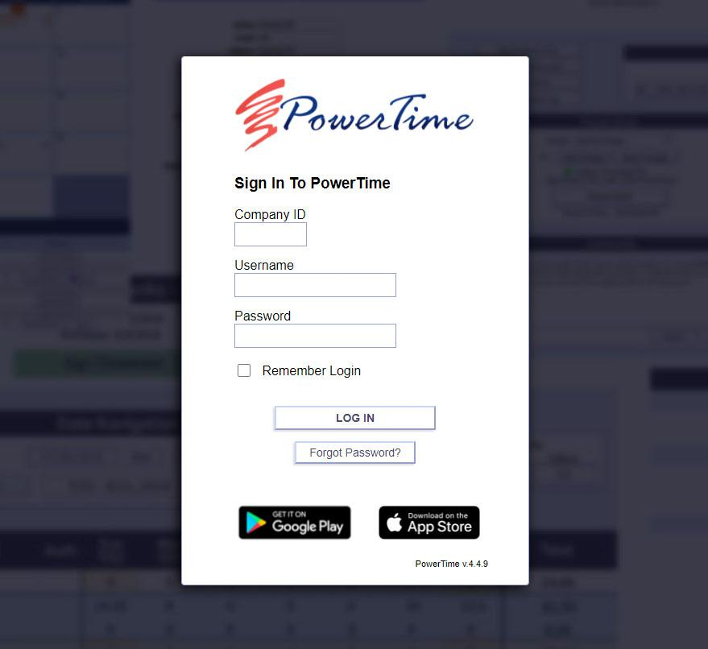

* Where: https://www.powertime.focusps.com
* Company ID: 4 digit pin number
* Username: Provided by Supervisor
* Default Password: Password1

# Employee Functions

* Record and Sign Timesheets
* Record and Sign Expenses
* Submit Time-off Requests
* View and Print Paystubs

# Employee Weekly Timesheet

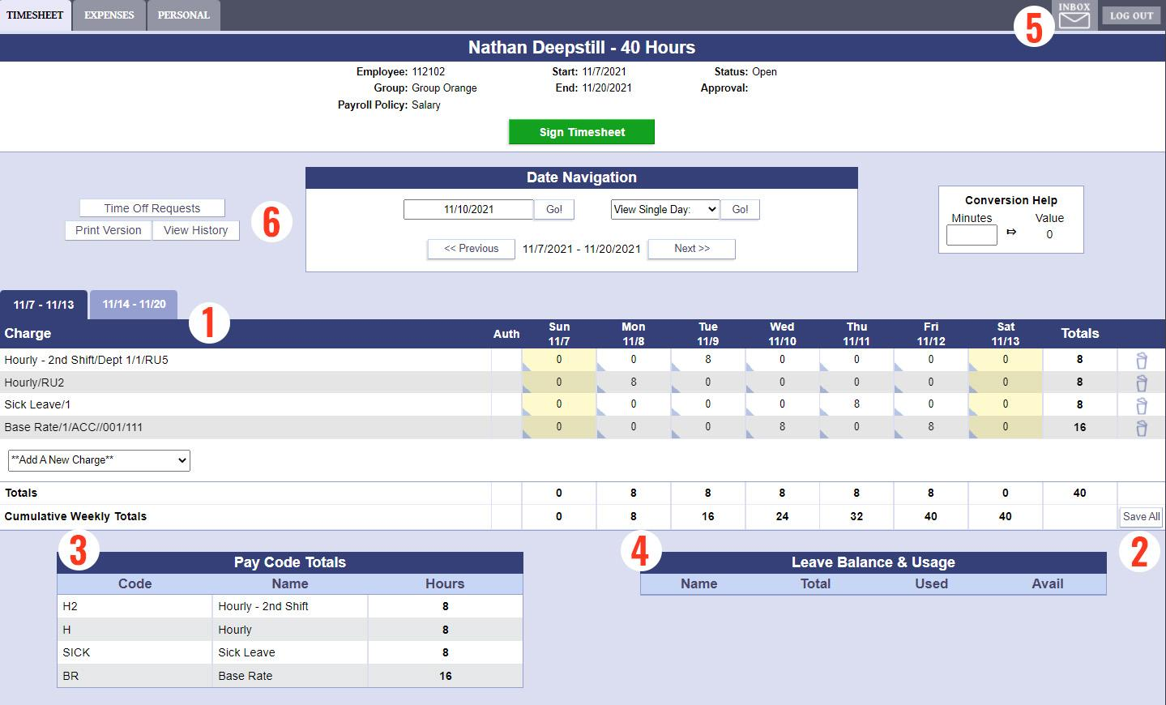

1. Input Hours Worked
2. Press Save to update
3. Pay Code Totals
4. Leave Balance & Usage
5. View/Reply to Messages
6. Browse Other Timesheets

# Add A New Charge

Charge Selector  
Used to add a charge to the current timesheet

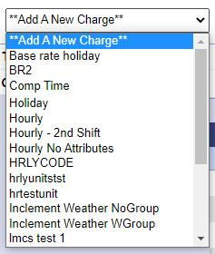

First, choose the Pay Type that you want to enter on the timesheet  
  
  
  
  
  
Add information for Cost Centers and/or Reporting  
Units as required. Click "Add Charge" when finished.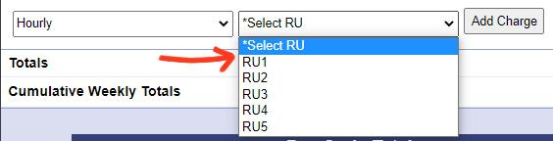

The new charge will appear on the Timesheet.   
You can now add hours to it.

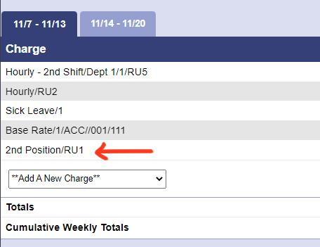  
  
Press "Save All" once you're done filling in hours.

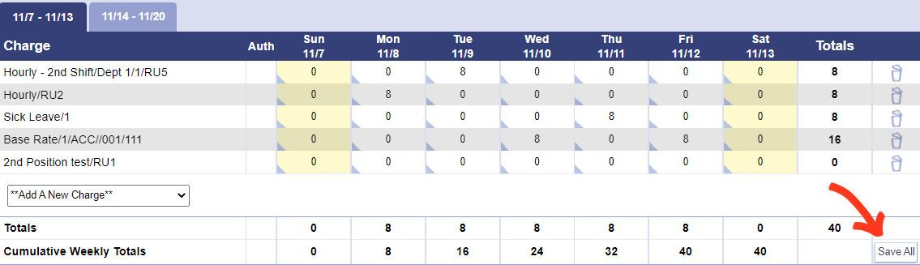

# Weekly Expense Sheet

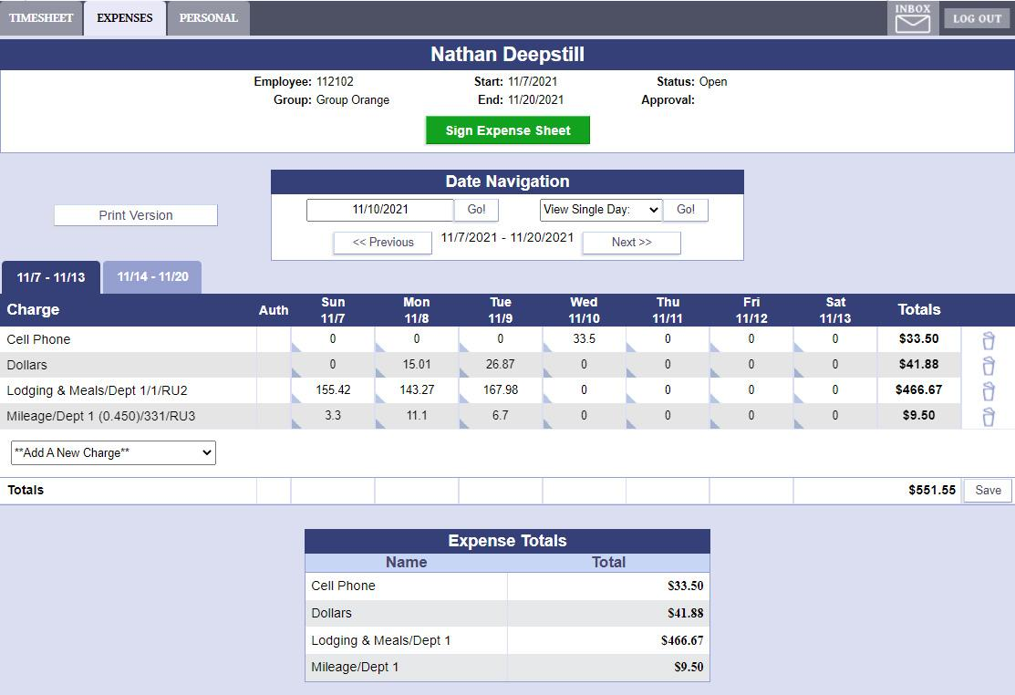

The Expense Screen works almost exactly like a Weekly Timesheet.

* Charges are added in the same way
* Enter expense amounts and click Save
* Mileage charges automatically convert to a dollar amount according to your company's set mileage rate.

# Personal Screen

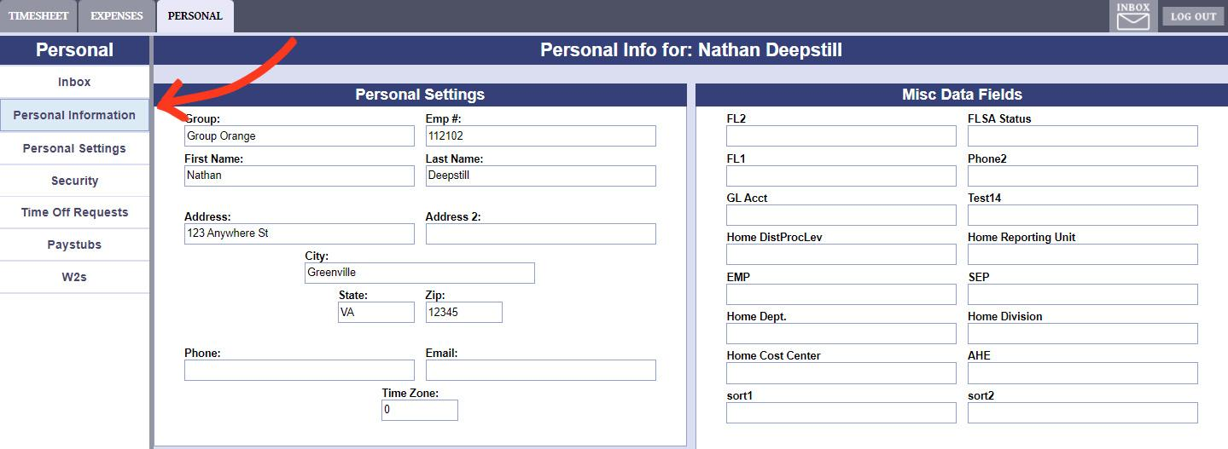

The "Personal" tab on the top of every page will lead to this screen.

Using the menu on the left side of the Personal section, Employees can access areas that will let them:

* Change their Password
* Set Favorite Charges
* Set their default charges for all new timesheets
* Submit Time-off Requests
* Read and Reply to Messages
* View their Paystubs and W2s

# Time-off Requests

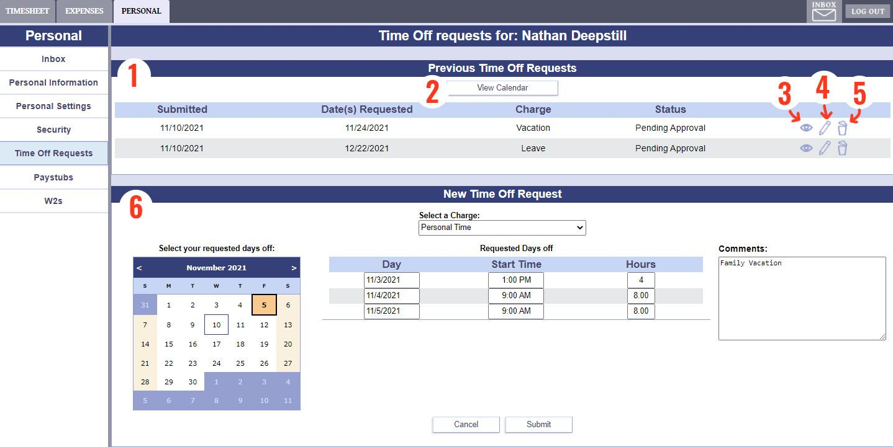

1. This Section displays your Time Off Request History and their status
2. "View Calendar" opens a large calendar with  
   your Time Off Requests displayed on it
3. View the details of this Time Off Request
4. Edit this Time Off Request (See #6)
5. Delete this Time Off Request
6. Use this Section to create a new Time Off Request, or to edit an existing one.

* Click a day on the small calendar to add it to your Request
* Select a Charge using the drop down menu
* Edit the number of hours and start time for each day if necessary
* Add a comment if required
* Press Submit to finalize the Request

# Electronic Paystubs

To see the details of a specific Paystub, click on it to select it, then click "View"

The "Print" button will open the selected paystub in a new window, with a layout suitable for printing.

# Pay Stub View

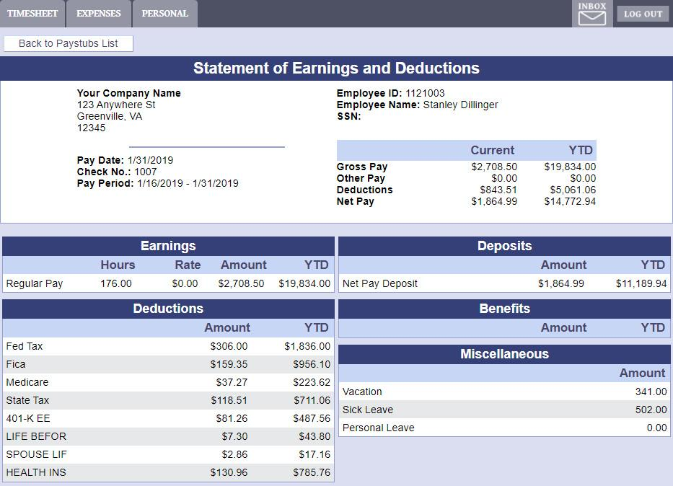

A detailed display of your earnings, deductions, and deposits.

# Supervisor Functions

Navigate to the Supervisor Area using the "Super" button  
in the Top-Right corner.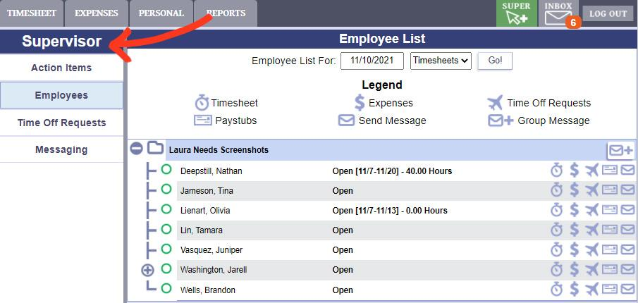

Once in the Supervisor area, use the menu to the left  
to access all the Supervisor's different tools.

Supervisors can:

* Review and approve Timesheets, Expense Sheets, and Daily Punches
* Check the List of Employees they supervise
* Manage their Employees' Time Off Requests
* Send messages to Employees individually or in a group

# Action Items

This is the first page Supervisors will see. Displays a list of items needing their attention.

The button in each row will open a window where the Supervisor can take the action that is needed.

# Supervisor’s Employee List

This page displays the hierarchy of Employees in the Supervisor's group.

1. Display Timesheet or Expense Sheet status for a specific pay period
2. Click the "+" and "-" symbols to expand or close group views
3. Timesheet/Expense sheet status column
4. Shortcut buttons to the corresponding employee's pages
5. Group Message shortcut

# View Time-off Requests

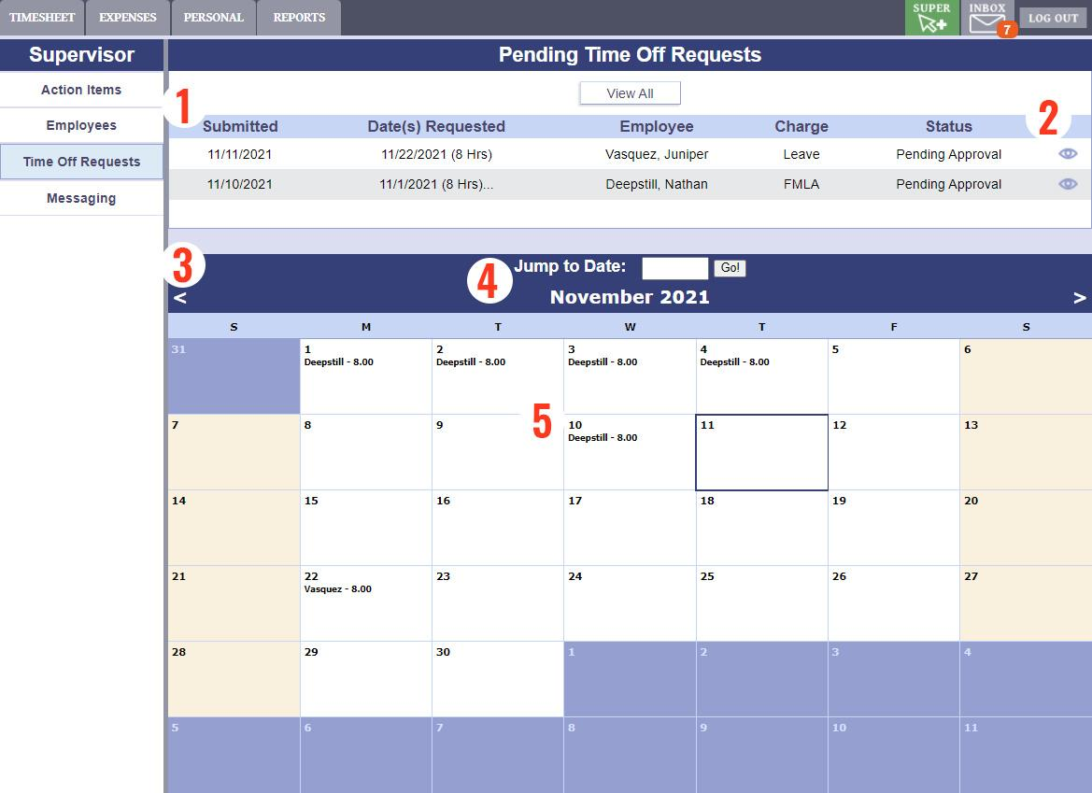

This page gives the Supervisor information about the Time Off Requests made by employees in their group.

1. List of recent requests
2. Opens a window to view and edit the request
3. Requests displayed on a calendar
4. Change months with the left or right arrow buttons, or enter a date to view.
5. Click a request on the calendar to view its details

# Approve Time-off Requests

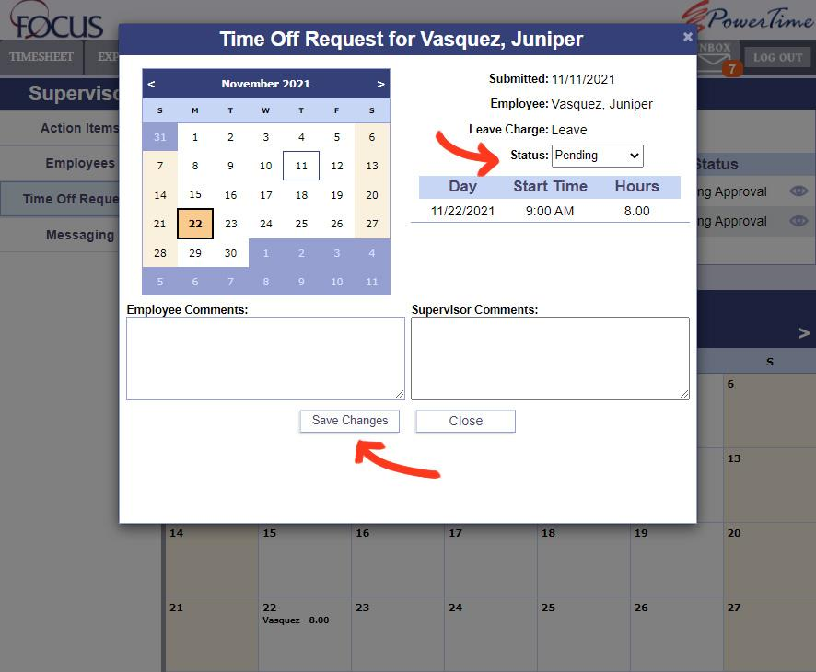

* Change Status of request to Approved or Denied
* Enter comments if required
* Save Changes when finished
* If approved, the time is automatically entered on Timesheet
* Employees can edit their requests if their status is Pending
* If a Request is edited, changing its status to Approved will update the Timesheet

# Send A Message

There are two methods a Supervisor may use to send a message.

1. Messaging Area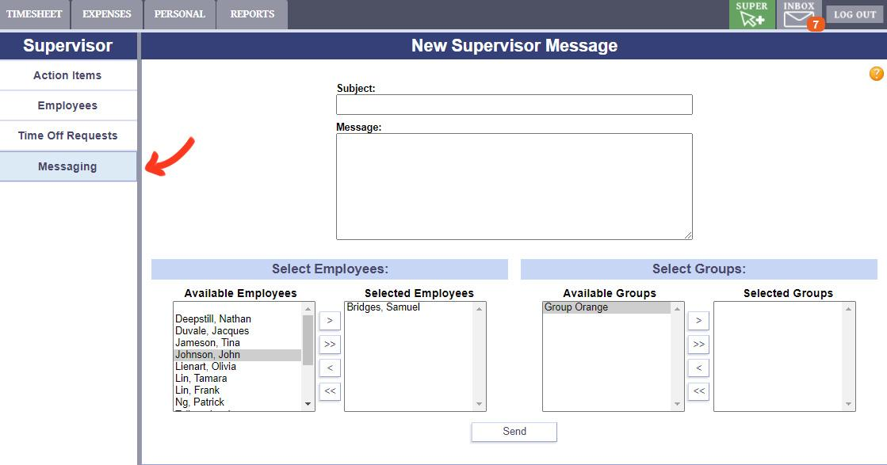

Use the menu on the left to navigate to the Messaging page.

To determine who should receive the message, use the arrow buttons to move Employees or Groups from the "Available" box on the left into the "Selected" box on the right.

Once the Supervisor's message is written and the recipients are selected, click the Send button to finish.

1. Employees List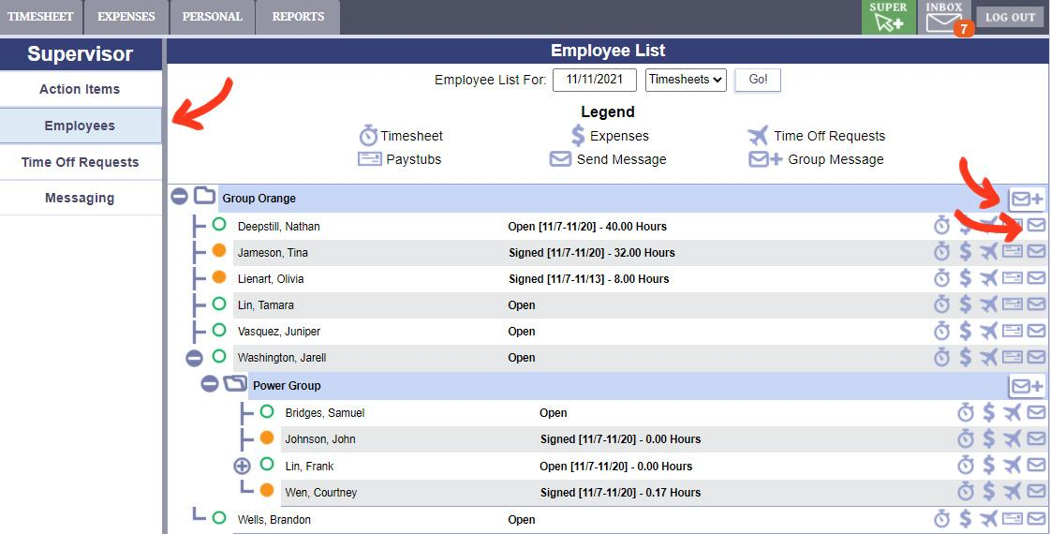

Use the menu on the left to navigate to the Employees List.

The envelope icons on the right side of the screen will open a message window for the corresponding Group or Employee.

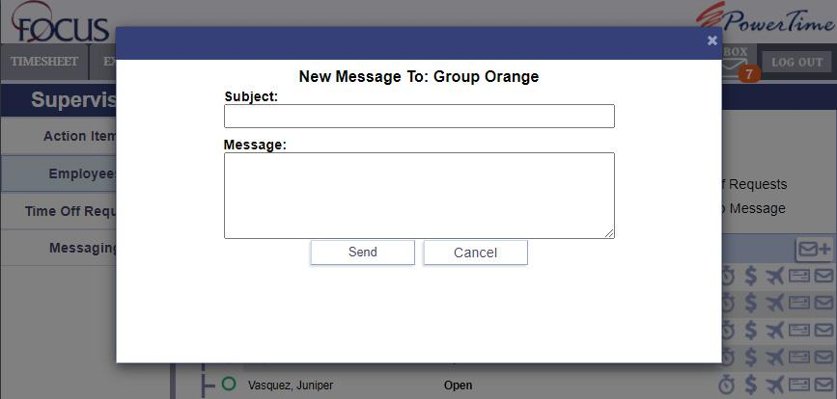

*Report List*

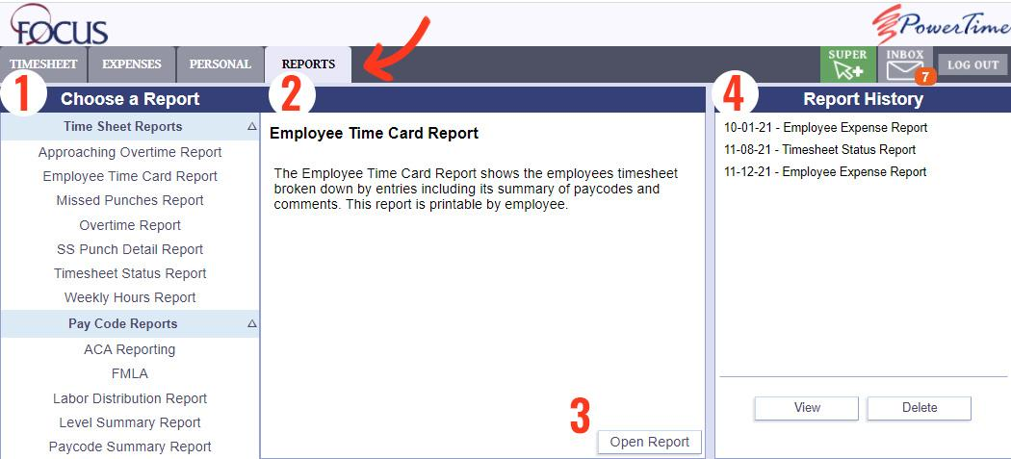

Supervisors and Administrators can generate a variety of reports for informational purposes. Supervisor reports are limited to employees in their group(s).

1. The list of report types. Click on one to select it and learn more about it.
2. Description of the selected report.
3. Open the settings for running the selected report.
4. List of reports that have been generated in the past. Click on a report and press "View" to see the archived report.

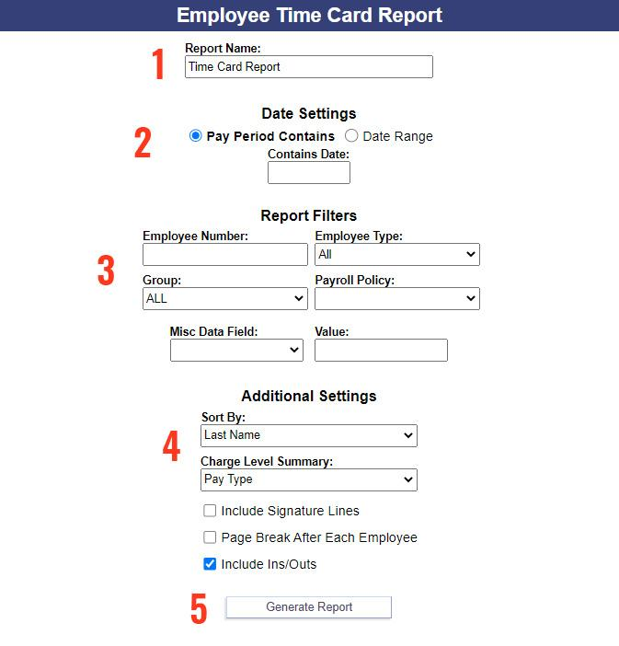

After clicking "Open Report", you will be taken to a new window where you can set up the report.

1. The name the report will have (in the Report History) once it's finished.
2. A pay period or a range of dates for the report to display data from
3. Filters the results by one or more of these properties. Optional.
4. Other settings, such as for how the report will be formatted
5. When ready, click this button to generate the report.

Depending on your settings, it may take a few minutes to generate your results. You can wait here for the report to finish, and it will be displayed automatically, OR you can close this page and view your results later in the Report History.

# Administrative Functions

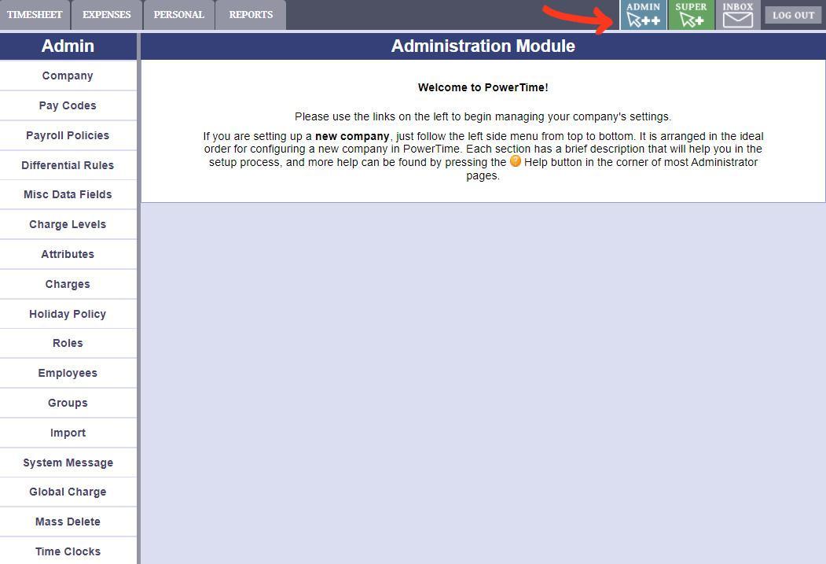

Click on "Admin" in the top right corner of any page to travel to the Administrator's section. Use the menu on the left to begin configuring various PowerTime settings.

If you need help, the ? symbol in the top right corner will provide more information about the settings on your current page.

You can also contact Focus Help desk at:   
[Support@focusps.com](mailto:Support@focusps.com) or (757)-873-9002

# Company Setup

This page sets up your:  
-General Company Information  
-Password Management and Rules  
-Company Logo  
-HTML-Capable welcome (Log-in) Message  
-Timesheet Agreement Message  
  
In the top-right corner, two additional sections can be accessed:   
IP Address Restrictions, and Sub-Company Management

# Pay Codes

This style of page will appear many times in the Admin section:   
A list on the left, and a details and settings area on the right (or below, for smaller screens). 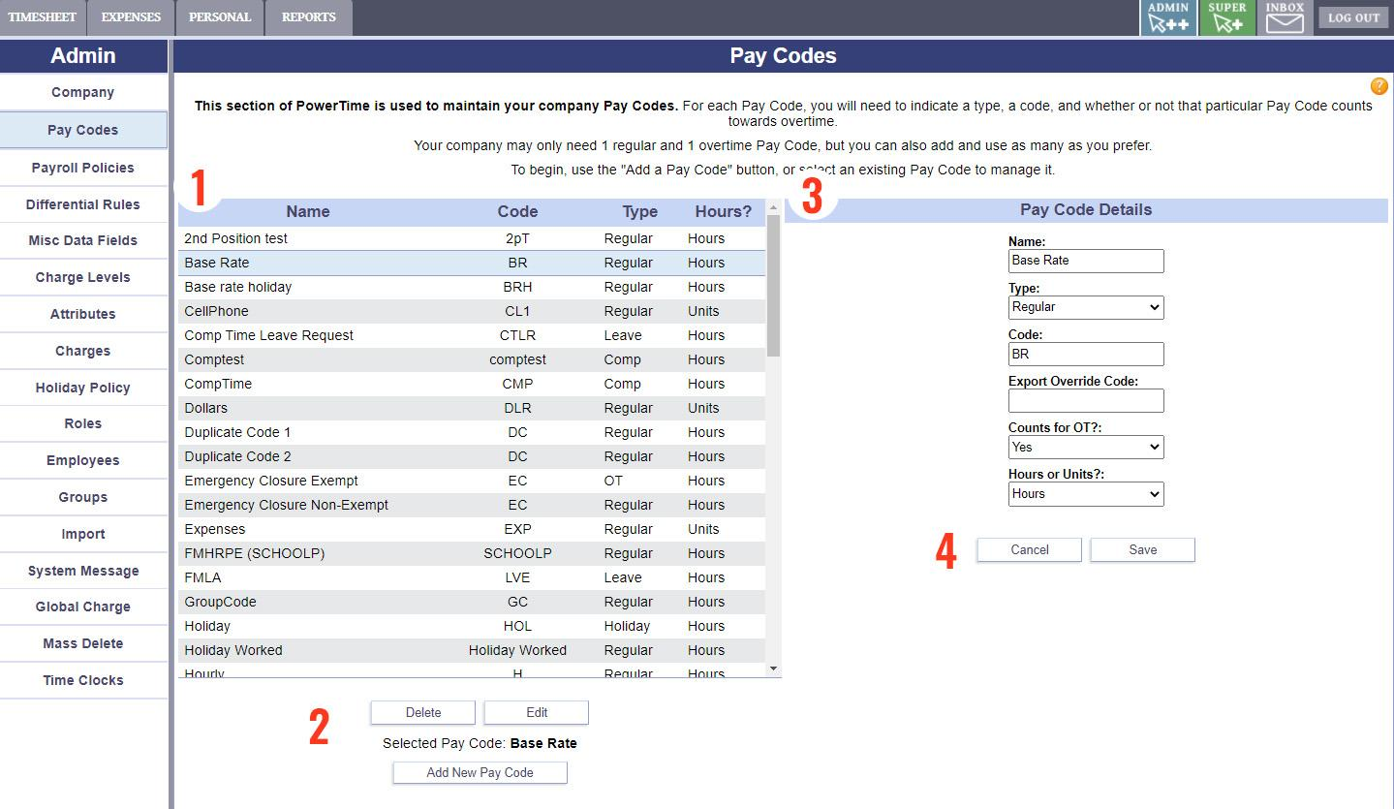

1. Click an Item in the list to select it
2. Edit or Delete the selected Item. Or, Create a new one.
3. Settings for the Item you are currently working on.
4. When finished, click Save to keep your changes, or Cancel to undo them.

# Payroll Policies

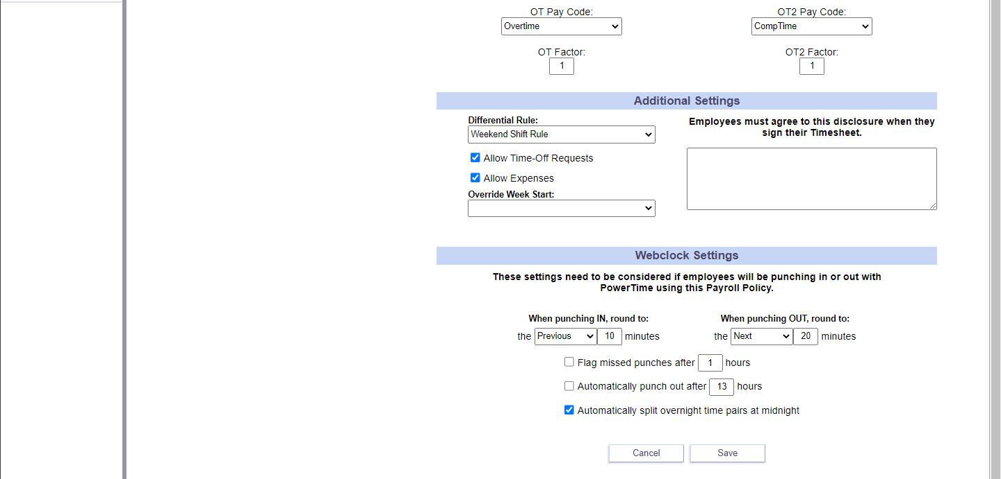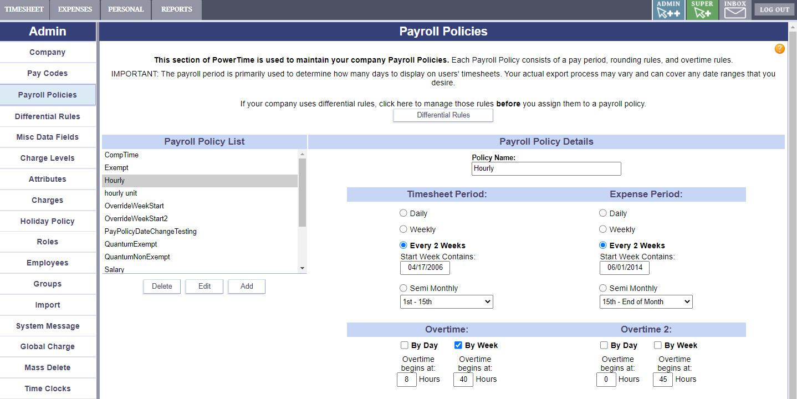

Delete, edit, add,or copy new payroll policies on this page.   
If you will be using Differential Rules, set those rules before assigning them to a Payroll Policy.

* Define Timesheet periods
* Set rounding Rules for Punch Employees
* Set Overtime Rules and Overtime Pay Code
* All Employees are assigned to a Policy (on the Employees Page)

# Differential Rules

Differential Rules modify the Pay Code rate when they are used during the times you set.

# Each Rule in the list (left side) can contain multiple times, rates, and Pay Codes that it applies to (right side).

# Miscellaneous Data Fields

# 

Misc Data Fields don't change how PowerTime works, but they can be a useful tool for recording and storing extra information about Employees or Charges.

# Charge Levels

Charge Levels are an optional setting that allows you to create a hierarchy for your charges. For example, your company may wish to split its Charges into 3 Levels: Location, Department, Task.

Create Charge Levels on this page, and then assign Charges to them on the "Charges" page.

# Attributes

Attributes are an optional feature of PowerTime that allows you to collect additional information when Employees use certain Charges on their Timesheets.

Type In: If unchecked, the options will be presented to the Employee using a drop-down list. If checked, Employees will type in their input.

Validate: If checked, the system will only accept the Employee's input if it's declared on the list below.

1. Edit this row
2. Set the Supervisor List for this Attribute
3. Delete this row

Use the Charges page to assign Attributes to certain Charges, and set up how they can be used with that Charge.

# Charges

Use the settings on this page to define the rules for each Charge.  
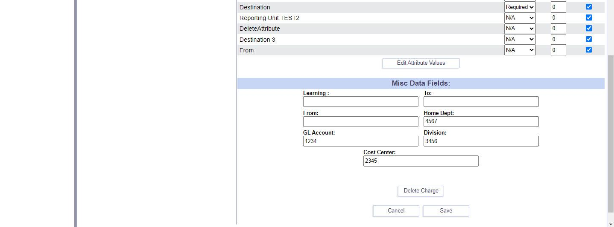

Use this page to activate/deactivate Charges, or set their names, short codes, charge levels, and Supervisors.

You can also set whether a Charge is an Expense (and the corresponding rules), which Attribute information should be collected when this Charge is used on a Timesheet, and any other Miscellaneous Data you might want to assign to it.

Use the "Assignable As Group" button to make that Charge into a group that you can organize other Charges into.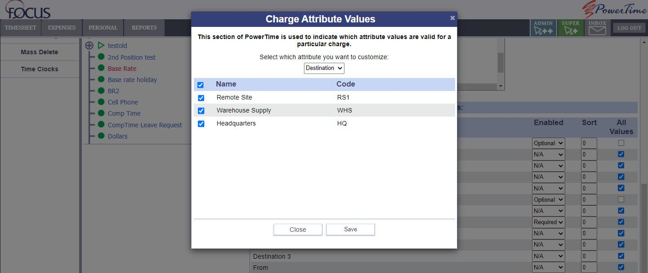

The "Edit Attribute Values" button will open a small window. Here, you can set which user inputs are valid for each Attribute assigned to this Charge.

# Holiday Policy

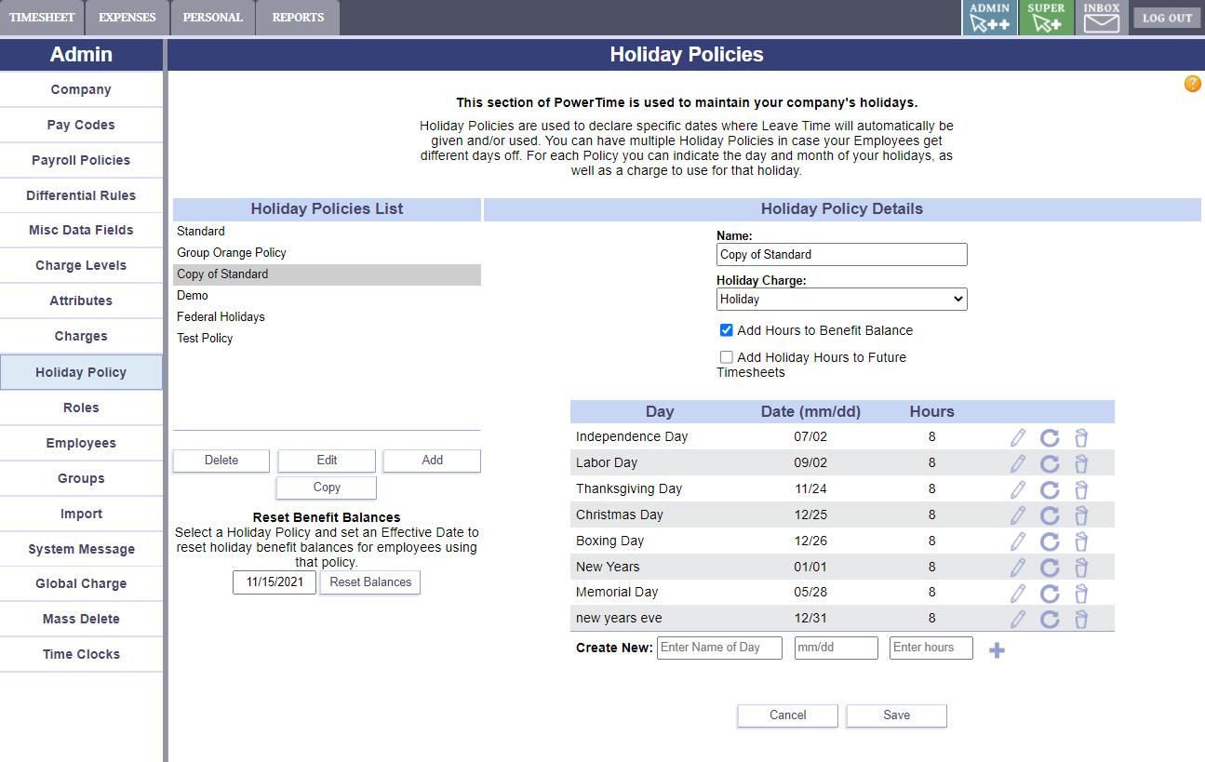

Holiday policies contain specific holiday dates and hours. They are assigned to employees on the Employees page.

The Holiday Charge you select is automatically added to the employees' timesheets.

# Employee Roles

An Employee's role determines which areas and tools they can access. You can create as many or as few roles as you'd like. Some uses of Roles include:

* Giving specific Admin functions to certain users
* Controlling access to Reports
* Setting up different kinds of Supervisors

# Employee List

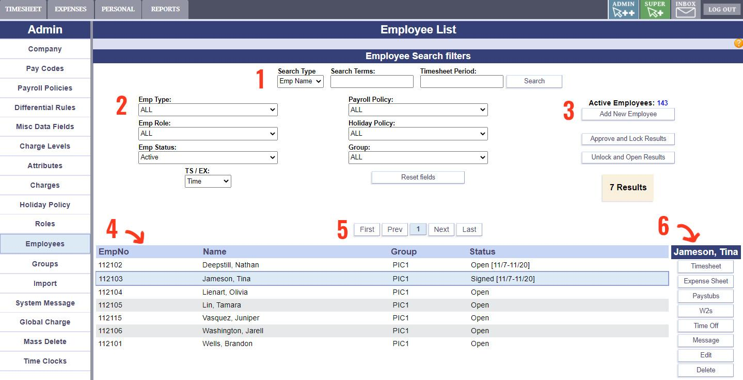

1. Search for an employee by name or by number. This can be left blank to see all employees based on your Filters (#2).
2. Filter your results using as many of these options as you need. Your results will update automatically.
3. Add a new employee, or Approve/Lock or Open/Unlock the timesheets or expense sheets of the currently shown employees.

NOTE: The Approve and Open actions CANNOT be undone

1. The list of employees found based on your search settings. Click on an employee to select them.
2. Navigate through the list of employees
3. These shortcuts open the selected employee's pages in a pop-over window

# Employee Attributes

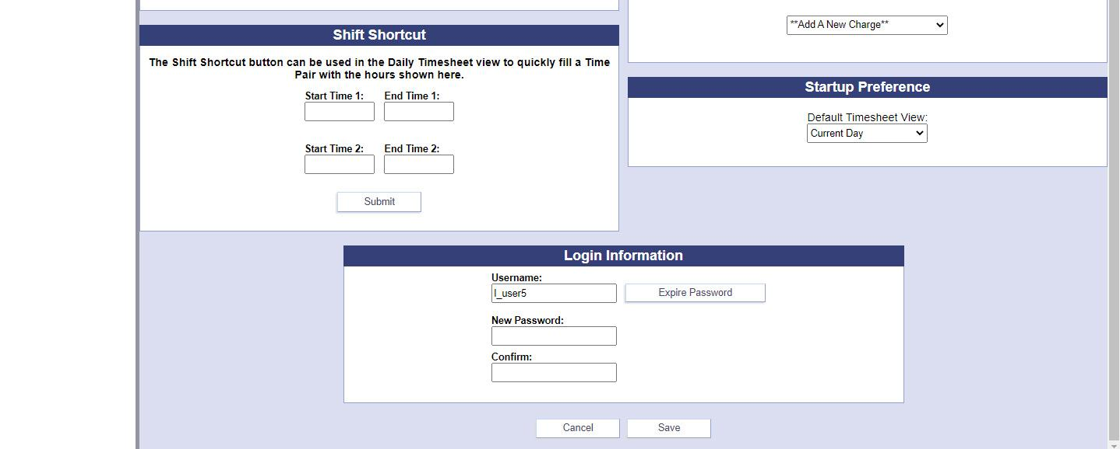

Use this page to change the selected Employee's information.

This includes:

* Personal information
* Role
* Group
* Payroll policy
* Holiday policy
* Available Charges
* Misc data
* Leave balance
* Preferences
* Login information.

# Employee Groups

* Sets Group Membership
* Sets Group Supervisor(s)
* Sets Approver(s)
* All employees must be in a group
* Each employee can be in only one group
* Charges can be assigned to a group

# Imports

PowerTime's Import Tool allows you to quickly and accurately transfer data into PowerTime. This can save a lot of time on certain tasks, such as creating large numbers of employees.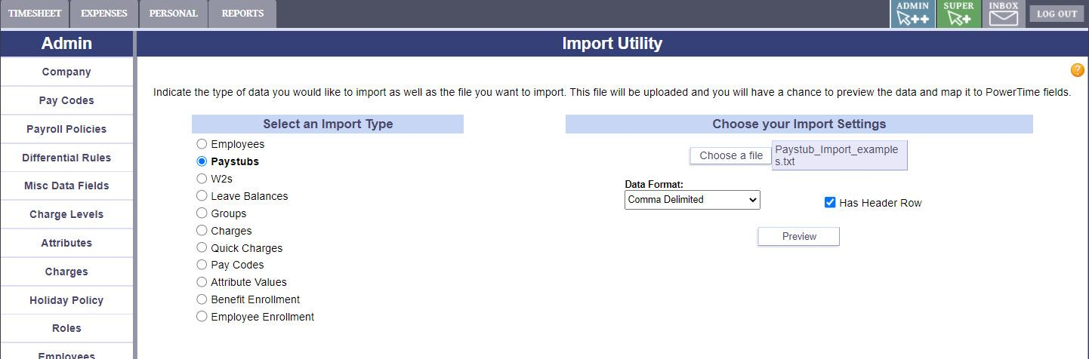

To start the Import process, first select the type of data you'll be importing. Then, select your data file and use the extra options to tell PowerTime how the data is formatted (for example, comma delimited, excel document, etc). Then, click "Preview"

Accepted formats: .csv, .txt, and Excel

Data Format: Is the data in your import file separated by commas or semi-colons?

Has Header Row: Check this if your file has a header row in the file that isn’t to be imported. (IE, “Employee name, employee number, totals”)

The next step in the Import process is to fit the contents of your import into PowerTime's data structure.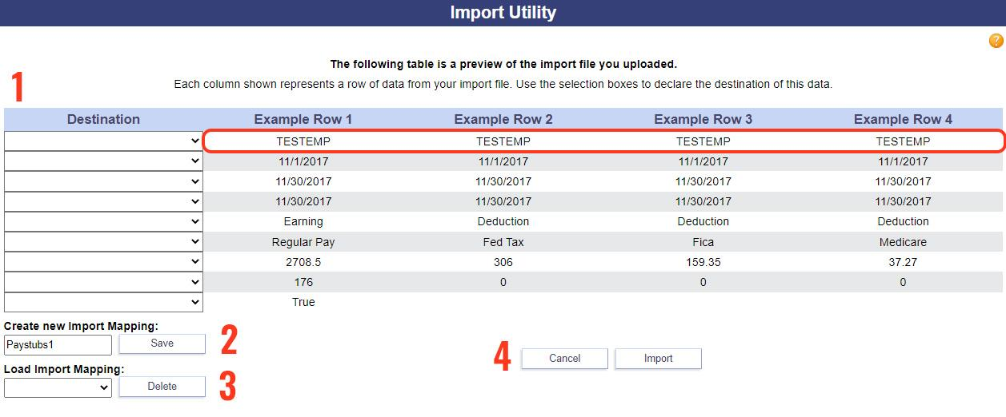

1. For each row in this table (example highlighted in red), use the "Destination" dropdown in that row to declare what kind of data that row contains.
2. If this is an import you expect to use frequently, you can save your Destination settings to a profile that you can use again later.
3. If you already have a profile saved, use this dropdown to load it.
4. Once your Destinations all look accurate, click "Import" to finish the process.

*Exports*

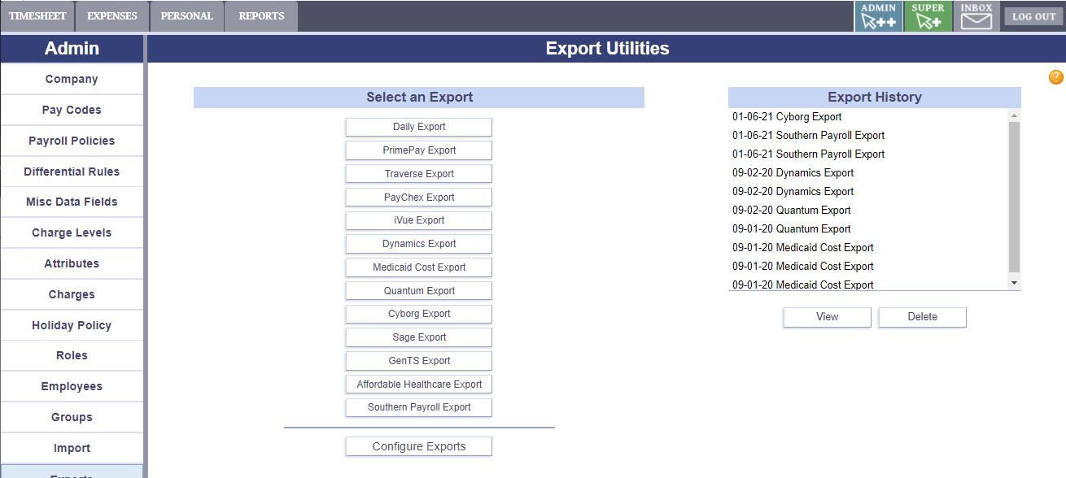

To generate an Export, select your Export type from the list. The "Configure Exports" button brings up a menu that allows you to choose which exports should be shown on the list.

To review a past export, select one from the Export History list and click "View"

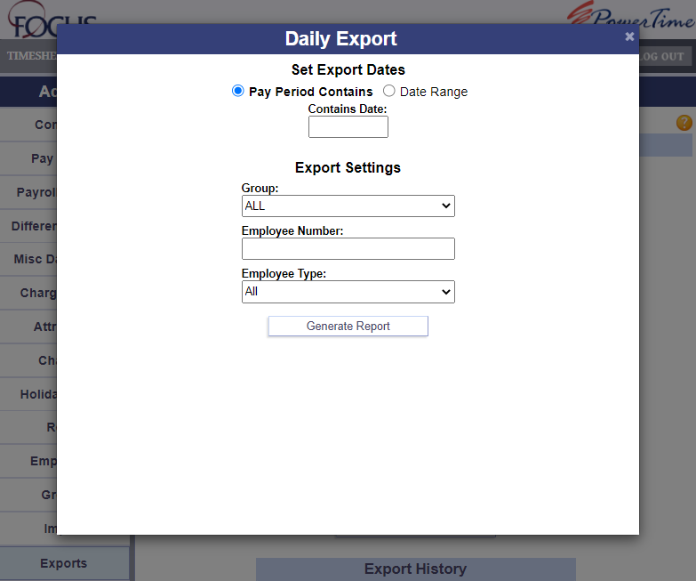

When you choose an Export type, this window will appear. Fill in the settings as desired, and click "Generate Report".

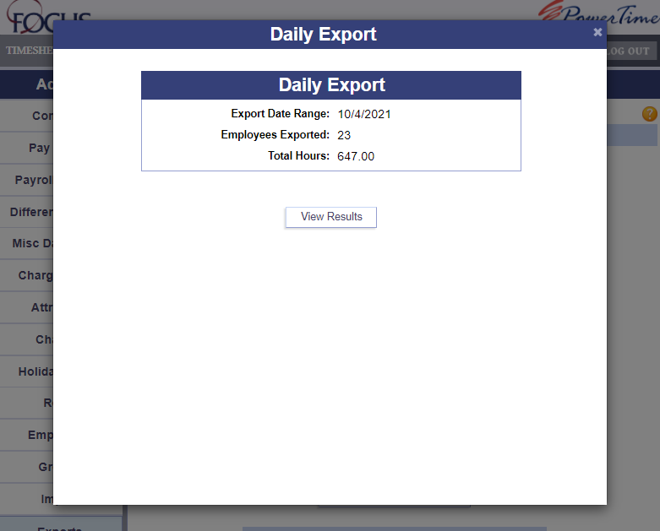When the export has finished, this screen will display a summary. Click "View Results" to receive your exported file.

*System Message*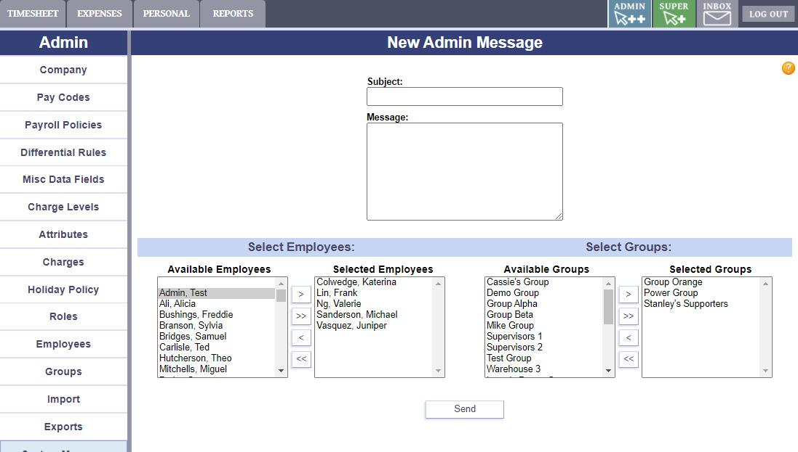

Admins with this permission can send messages to as many Employees or Groups as needed. Move Employees or Groups from the "available" box to the "selected" box to add them to the list of recipients. Compose your message, then click "Send" to finish.

*Global Charge*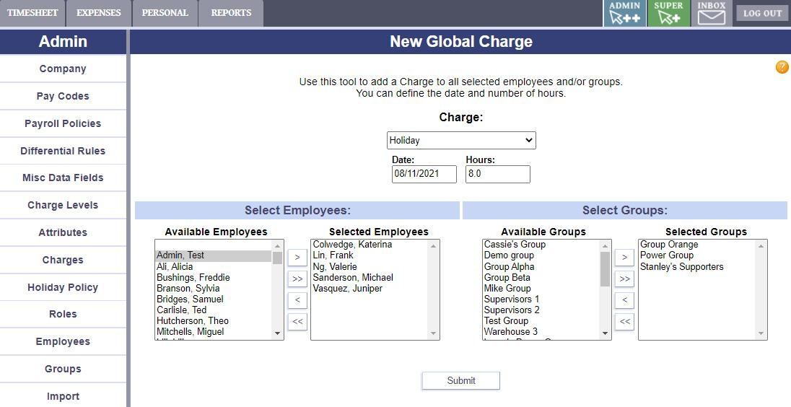

The Global Charge module allows an admin to add a desired charge to any employee(s) or group(s) they choose.

The Admin can choose the Charge, associated Attributes, the Date, and the amount of Hours.

*Mass Delete*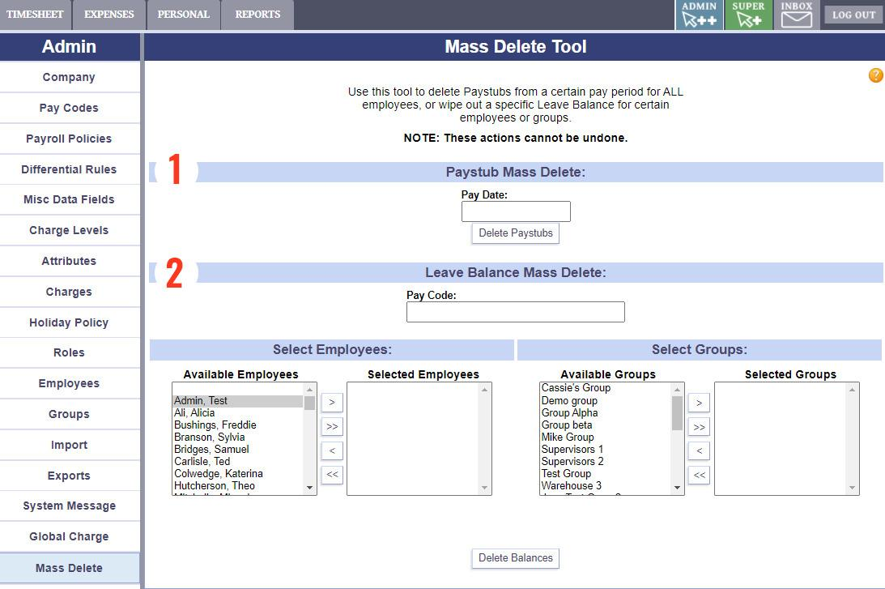

The mass delete module allows an admin to delete Paystubs of a selected pay period for ALL employees, OR to remove the leave balance from a pay code for certain employees. This can be used to correct for possible bad information from an import. This will have no impact on the functionality of collecting timesheet data.

Use Section 1 to mass delete Paystubs.

Use Section 2 and below to delete Leave Balances.

NOTE: These actions CANNOT be undone.

*The Pop-over Window*

Many buttons and tools will open a small window containing other pages in PowerTime. This "pop-over window" allows them to perform tasks without losing their place on the page they came from.

To close the window, click the 'X' button in the top right corner, click outside the window, or press the cancel/close button on the bottom (if available).

If required, don't forget to use the save/confirm button before closing the pop-over window, or any changes may be lost.