

# PowerTime Employee Training Manual

# Accessing PowerTime

1. [Open your browser (Internet Explorer, Edge, Chrome, Firefox) and navigate to your PowerTime URL](https://www.focus-servers.com/powertime/login.aspx)
2. Enter Your Company ID
3. Enter Username: Your Employee Number
4. Enter Password: Powertime

* If this is your first login, you will be asked to change the password.

1. Click on “Login.”

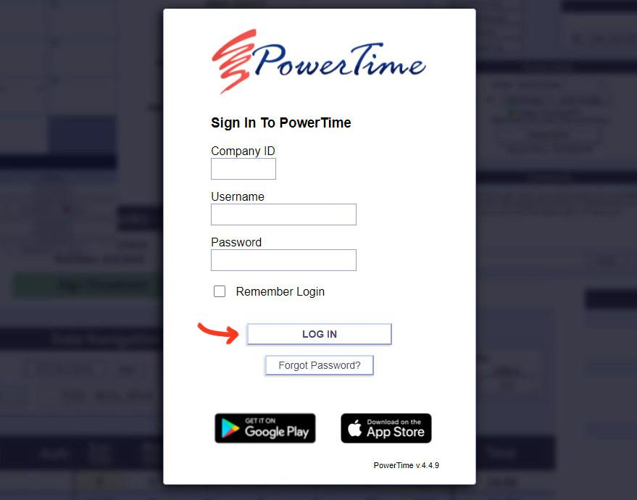

# The Pop-over Window

Many buttons and tools will open a small window containing other pages in PowerTime.

This "pop-over window" allows you to perform tasks without losing your place on the page you came from.

If required, **don't forget to use the save button** before closing the pop-over window, or you might lose any changes you made.

**To close the window**, click the 'X' button in the top right corner, click outside the window, or press the cancel/close button on the bottom (if available).

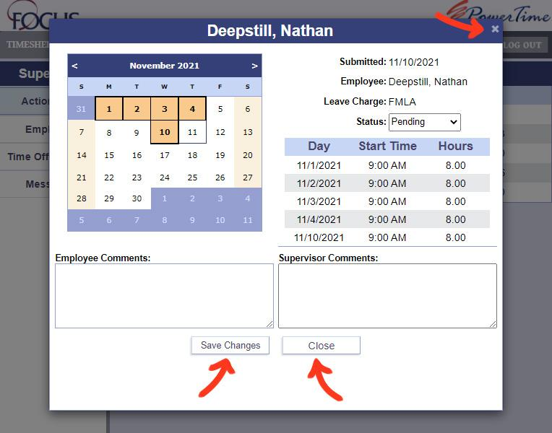

# The Timesheet

The timesheet is the primary page responsible for time entry and review. As a user you can go to previous and future timesheets to review hours entered. You will also have access to your summarized pay codes entered as well as your current available leave balances. To review or access daily time transactions simply click on the date at the top of the time entry columns.

1. Click on the “Timesheet” tab to access the weekly display of your timesheet.
2. Click on “Previous” or “Next” if you want to see other time periods.
3. To review daily transactions, click on the actual day, an example would be “Tue 6/18.”
4. Review your Leave Balances. Approved current and future leave requests will show in the “used” column. Leave will be imported into PowerTime as it is accrued.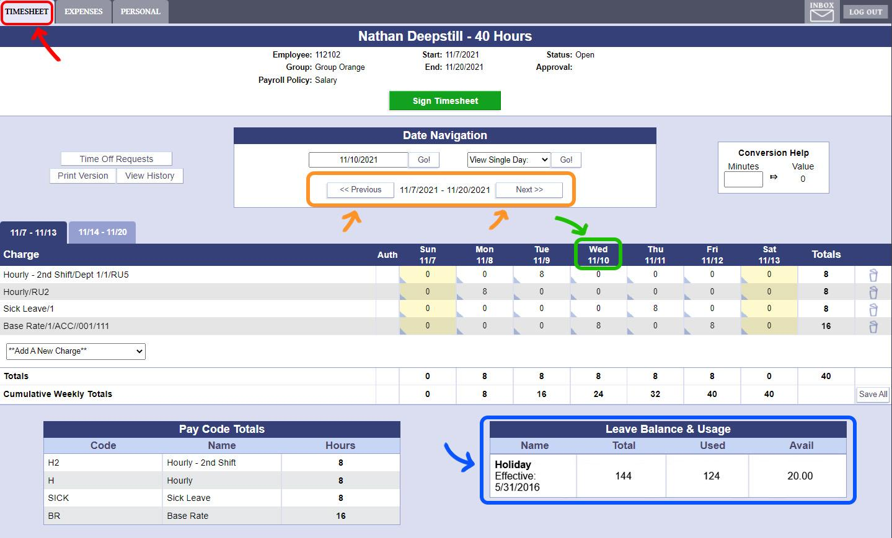

# Entering Time

Time entry on the weekly screen is done by adding charges to the timesheet and then applying the hours to the appropriate charge. This is done using the “Add a new charge” drop down selector just below the main timesheet columns pane. Simply choose your charge, choose your reporting unit and the charge line will be added for use.

1. Click on the charge dropdown box.
2. Select the charge to use
3. Select the reporting unit/department, if required
4. Lastly click Add Charge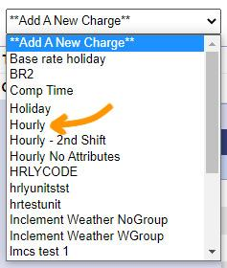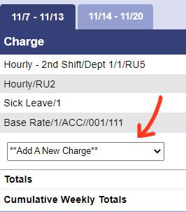

Following the steps listed on the previous page, PowerTime will allow you to have as many rows as needed for your time entry. 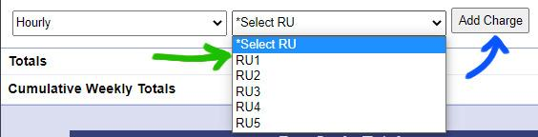

After adding the charge lines you should now be able to enter hours on it. To enter your time:

1. Click in the entry boxes and type in the number of hours needed for each of the days required
2. Click the Save All button to save your changes

If you wish to delete the time from a single day:

1. Click into the charge line entry box on the day to be removed, and change the number to zero
2. Click Save All

To delete an entire Charge Line from the Timesheet:

1. Click the Delete icon in the row you wish to remove. This change does not need to be saved, and cannot be undone.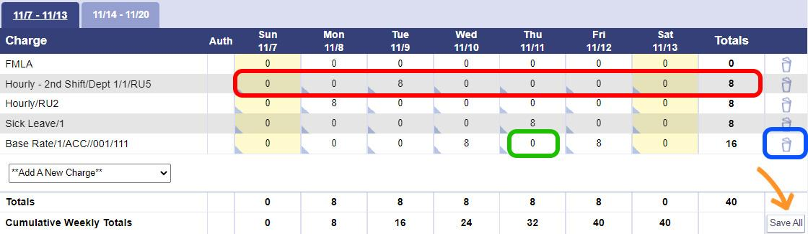

# Signing The Timesheet

Once time entry is complete, the final step for the timesheet is for the user to Sign it. Signing the timesheet will put the timesheet in a state of pending approval. Once the supervisor has approved it, the timesheet will Lock and no longer allow editing.

1. Check that all time entries are correct
2. Click the Sign timesheet button

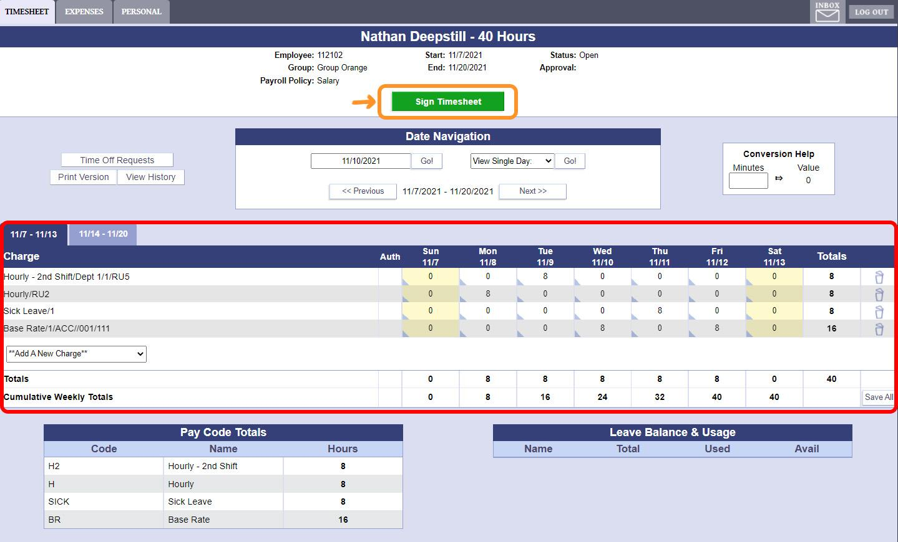

In order to sign the timesheet you will need to accept the disclosure statement. This disclosure statement will certify that you acknowledge that the timesheet is accurate and that you are officially submitting it to your supervisor.

1. Click OK to sign your timesheet

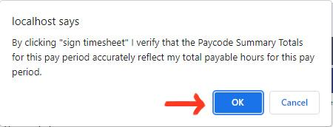

# Message Inbox

Along with basic navigation PowerTime has a built-in messaging system allowing your supervisor to contact you. This is located in the upper right of any page, OR through **"Personal"** from the top menu, and then **"Inbox"** on the left side.

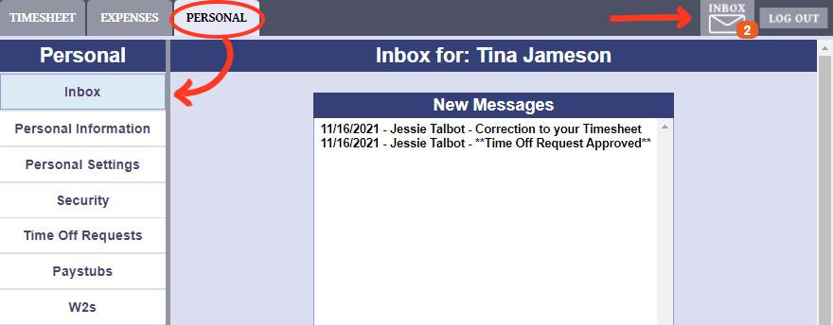

List of Unread (New) Messages. Click on a message to open it

All messages will always be available in the Message History area. Use the Search Filters to help you find a specific message.

Details about the currently selected message. If you need to reply to the message, click "Write a Reply"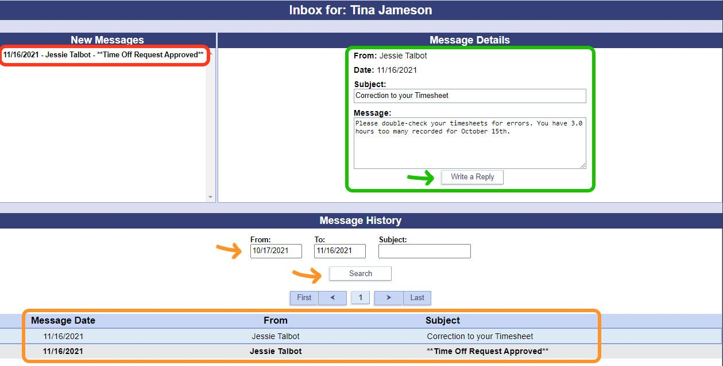



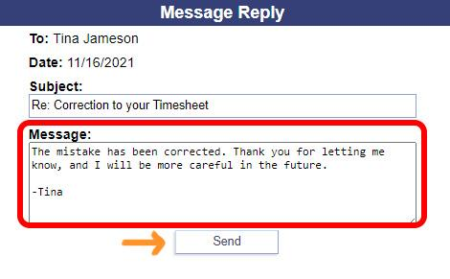

Replying to a message uses the New Message box shown to the left. It is as simple as writing an email. The subject should be filled out for you, however you can change it if you wish to do so.

1. Type in the response message you wish to send to your supervisor
2. When finished, click send.

# The Personal Tab

The personal tab is an area for users that contains information and abilities specifically for the user. The menu on the left-hand side of the page will take you to different parts of the Personal section.

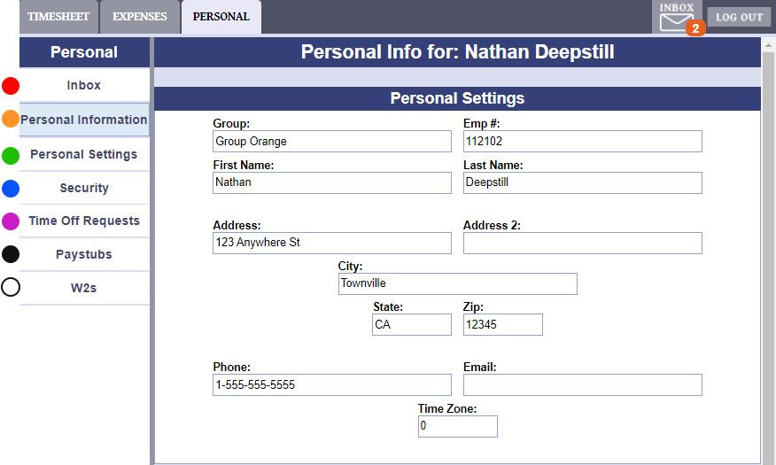

1. Message Inbox. Here, you can read and reply to messages sent to you by your Supervisor(s) and Admin(s)
2. Basic information about you, the user. This cannot be changed by the user. If you see an error, contact your PowerTime Administrator
3. Set up your favorite charges (charges that are added to each timesheet automatically), favorite shifts, or other settings.
4. Change your password and security question here
5. Manage or create requests for time off
6. View and/or print any of your Paystubs
7. Download copies of W2 forms for tax purposes

# Requesting Leave

1. Click on the “Personal” tab, then "Time Off Requests". This Time Off Requests page has two sections.
2. List of your Time Off requests, and their status
3. Create a new Time Off Request, or edit the selected Request

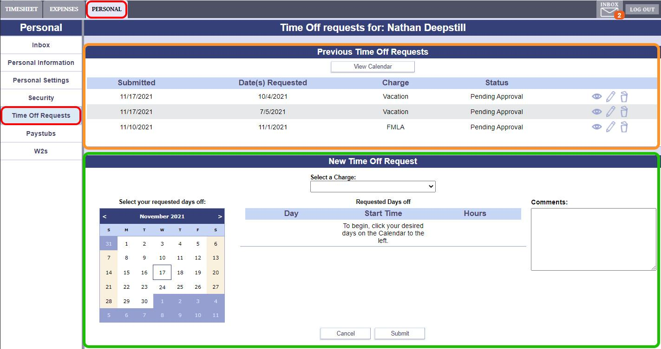

To submit a new time off request or edit an existing request follow these steps:

1. Select the leave charge you want to use. 
2. Click on dates in the calendar to add dates to this request
3. Modify the date, start time, and amount of hours if desired
4. Write a comment to explain the request
5. When you're finished, Submit the request. To discard your changes, click the Cancel button.

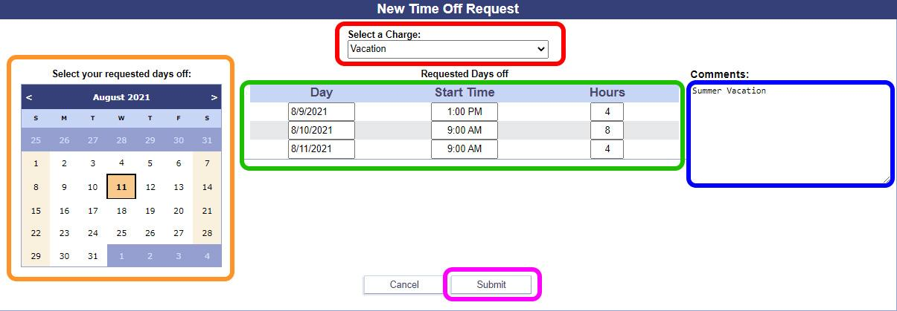

**After submitting your request, you can view it at any time in the Previous Time Off Requests section at the top of the page.**

# Favorite charges

Favorite charges allow you as the user to set which charges will be automatically added to your timesheet each week. It works very similarly to how a charge is added to the timesheet.



1. Click the personal Tab
2. Click on “Add A New Charge” in the  
    favorite charges section, and select  
    the desired charge from the list

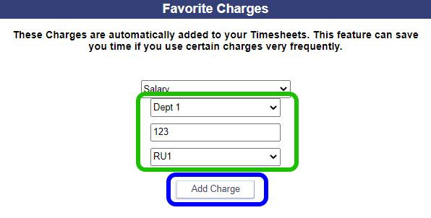



1. If required, add any Attributes, such as Reporting Unit
2. Click "Add Charge" when you're finished.

Your charge should appear as part of a list, as shown **below**. If you no longer need the charge to be automatically added to every timesheet:  
 5. Click the Delete icon to remove the favorite charge.

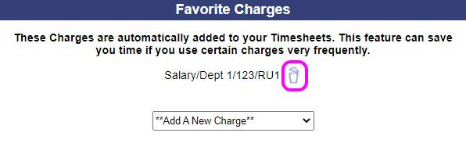

# Entering Expenses

1. Click on the “Expenses” tab.
2. Click on the drop down menu labeled “Add a New Charge.”  
   
3. (See Below) Pick the expense you want to be reimbursed, for example “Mileage”. Fill in the extra Attributes if required, then click "Add Charge"

**NOTE:** This is the exact same method as used on the weekly timesheet.

1. On this new charge line, enter your expense values on the days needed
2. Save All Entered Values

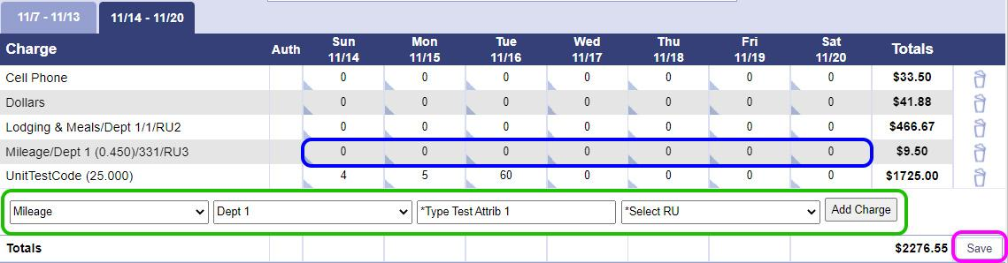

Some expenses will require comments or receipts to explain the expense. In order to submit these you will need to use the daily expense screen.

1. Click on the name of the day you wish to add comments or receipts to.

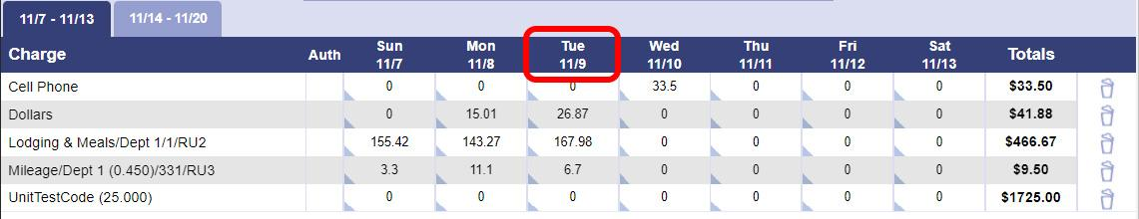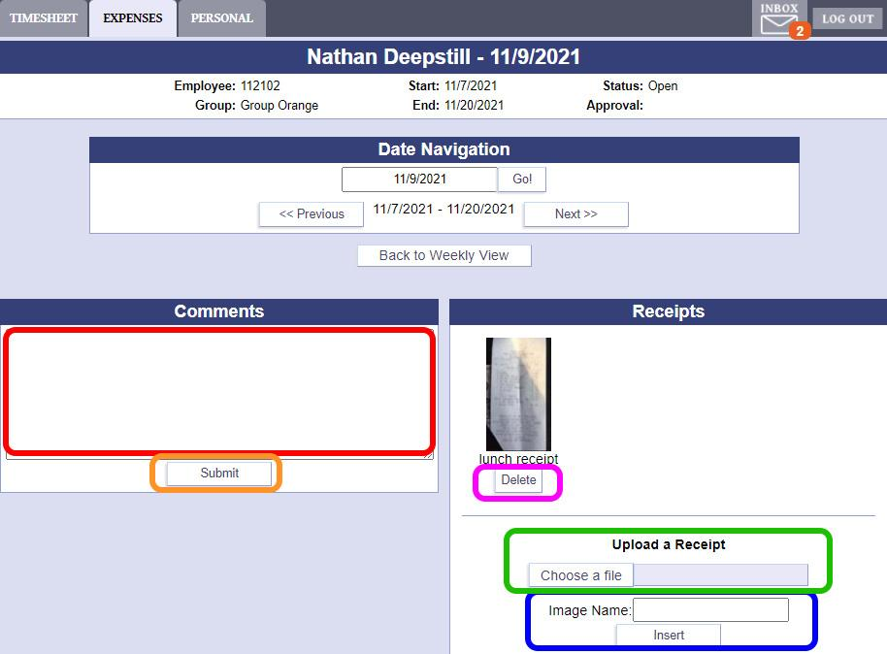

To Add Comments:

1. Type your comment in the box
2. Click Submit

To Add Receipts:

1. Select an image file of your receipt  
    (support formats: .jpg, .png, .gif)
2. Give the image a name, and click Insert

If you need to delete a receipt's image,

1. Click the Delete button under the  
    image you wish to get rid of.

# Signing the Expense Sheet

After you complete your expense sheet entries and have verified that they are accurate, the final step is to sign your expense sheet to submit it to your supervisor for approval. Just like the timesheet, this is done using the Sign Expense sheet button.

1. Click the Sign Expense Sheet button to submit it for supervisor approval 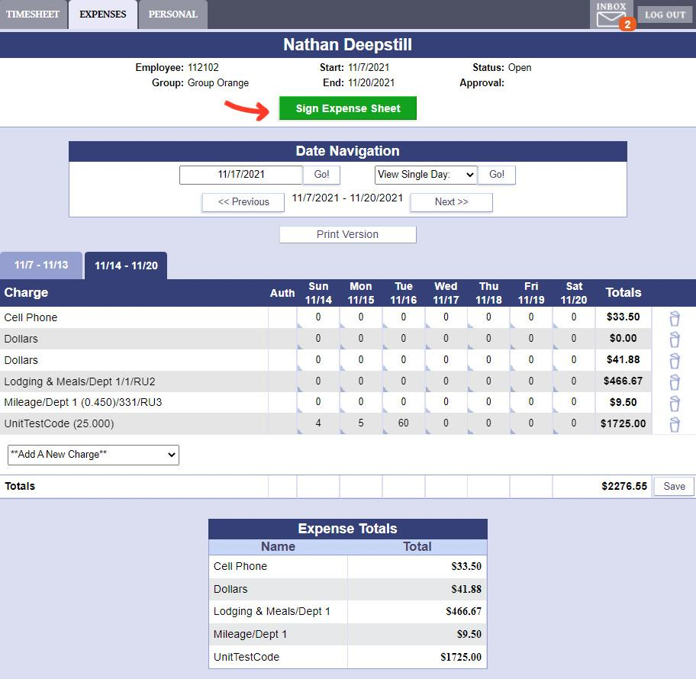

# Review Pay Stubs

Your employer may make your paystubs available through PowerTime. To review your paystubs, click on the Pay Stubs tab in PowerTime.

1. Click on the Personal tab, then Paystubs
2. Click on a Pay stub to review
3. Click View or Print. These both display the same information, just in a format that is better suited to screens or to printing, respectively.

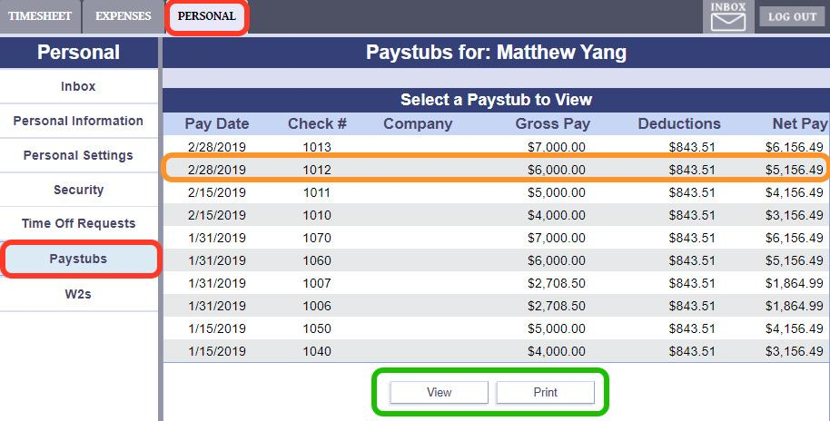

# View of a Paystub

The Paystub view will display your pay information broken down into several sections.

1. General Paystub information
2. Gross Totals
3. Earnings
4. Deposits
5. Deductions
6. Benefits
7. Miscellaneous