PowerTime Supervisor Training Manual

# Supervisor Tab

The supervisor tab is the main control point for supervisory action.

To access the Supervisor area:

1. Click on the “Supervisor” tab in the top-right corner of almost any page.
2. This side menu will take you to your different tools
3. Action Items List: A list of items awaiting supervisory attention. This is the default page for the Supervisor area.
4. Click on any button in the Action Items list to go to the described area where you are needed

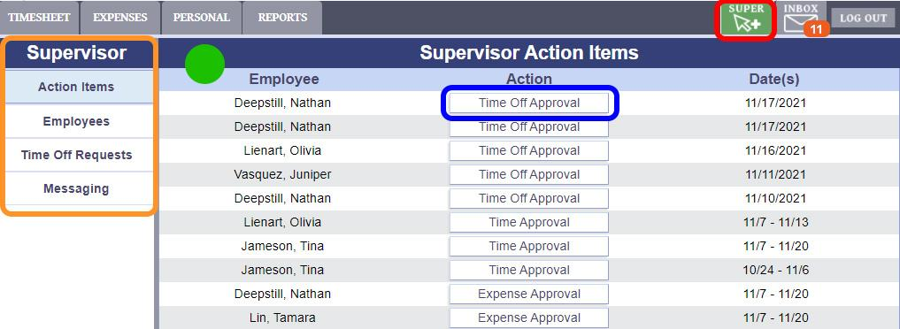

# Employees List

The Employees list displays a tree view of all employees you have responsibility for. 

1. Use the Employees button on the Supervisor menu to reach this page
2. Use these filters to switch to Timesheet or Expense status, and to display that status for a certain date.
3. Use the "+" and "-" signs to expand or collapse the groups of employees
4. Provides timesheet status information at a glance. Open timesheets are indicated by a hollow green circle, signed sheets by a solid orange circle, and Locked/approved sheets by a solid grey circle.
5. These shortcut icons will quickly take you to the corresponding employee's pages, or send them a message. Refer to the Legend on the top of the page for information on each symbol.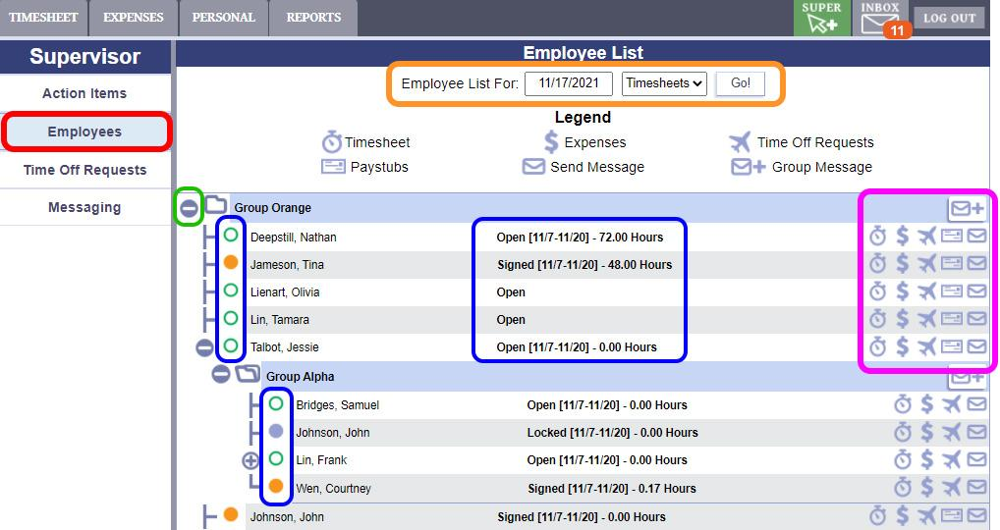

# Viewing and Approving a Timesheet

After clicking on the “Time Approval” action item or the Timesheet button in the Employee List, you will be taken to the supervisor view of that employee’s timesheet. This will be noted in red and yellow above the timesheet information pane.

1. Use the “Previous,” “Next,” or “Date Picker” to navigate across pay periods.
2. Use the tabs above the timesheet section to navigate multiple weeks in the pay period if available.
3. To edit the hours, click in any of the time entries and type the hours in the box. When finished, click “Save” at the bottom right. To edit the time pairs, click on the date above the column of entries. That will take you to the day screen to edit the time pairs directly.
4. If the Timesheet is accurate and the employee has signed it, you may lock the timesheet by clicking "Approve Timesheet". At this point, only an Admin can unlock the Timesheet.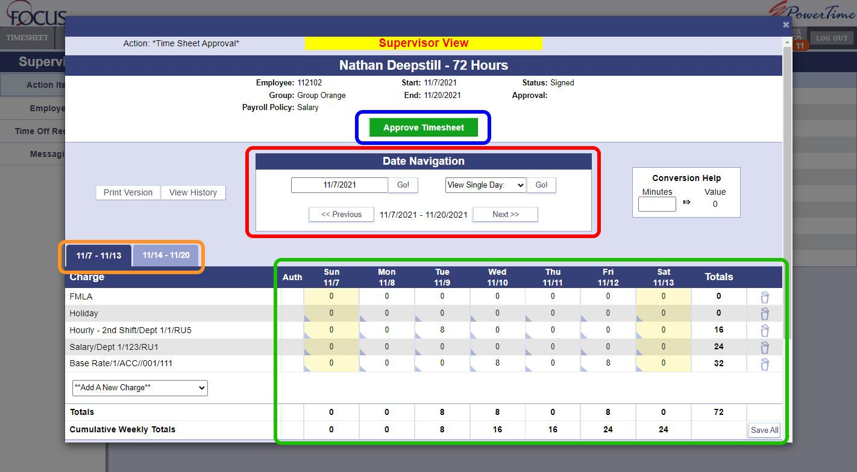

# Accessing Employees You Don't Supervise Directly

Sometimes, you may have an individual transferred into your group temporarily. If you are set as a supervisor for a department code, when individuals use that department code on their timesheet, PowerTime will grant you access to these individuals so that you can authorize the use of your department code. They will appear in the Employee List as Projects With Outside Employees.

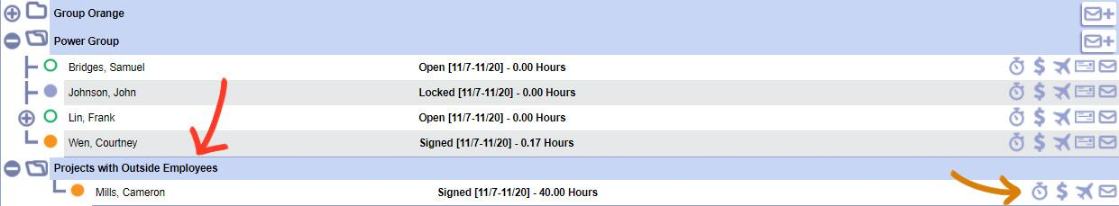

Clicking on the TS button next to this employee will open their Timesheet. However, as you are not this person's direct supervisor, you will have limited control of the timesheet. You cannot approve it, but after ensuring that all the information is correct, you can put your initials into the AUTH box for the row you supervise.

1. Fill in your initials for the Auth Field
2. Click Save. This will notify their direct supervisor that the user was authorized to use this department/RU.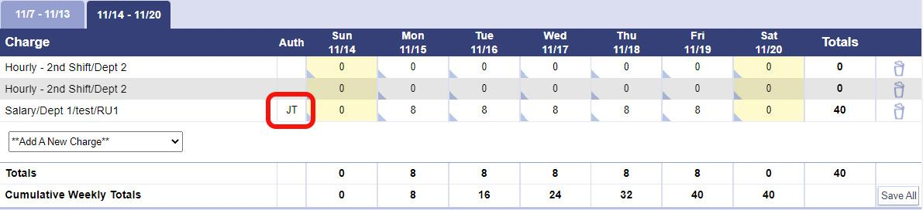



# Approving, Editing, or Denying Time-Off Requests

To access the Time Off request system in PowerTime as a supervisor. Click the button labeled “View Results” in the time off request area of the supervisor tab.

1. To access the Supervisor's Time Off Request System, click "Super" in the top right, then "Time Off Requests"
2. This area contains the list of pending Time Off Requests
3. A calendar view of all dates being requested off, and who requested them
4. The approve or deny any request, click on the Eye icon in the List, or click directly on the request in the calendar.

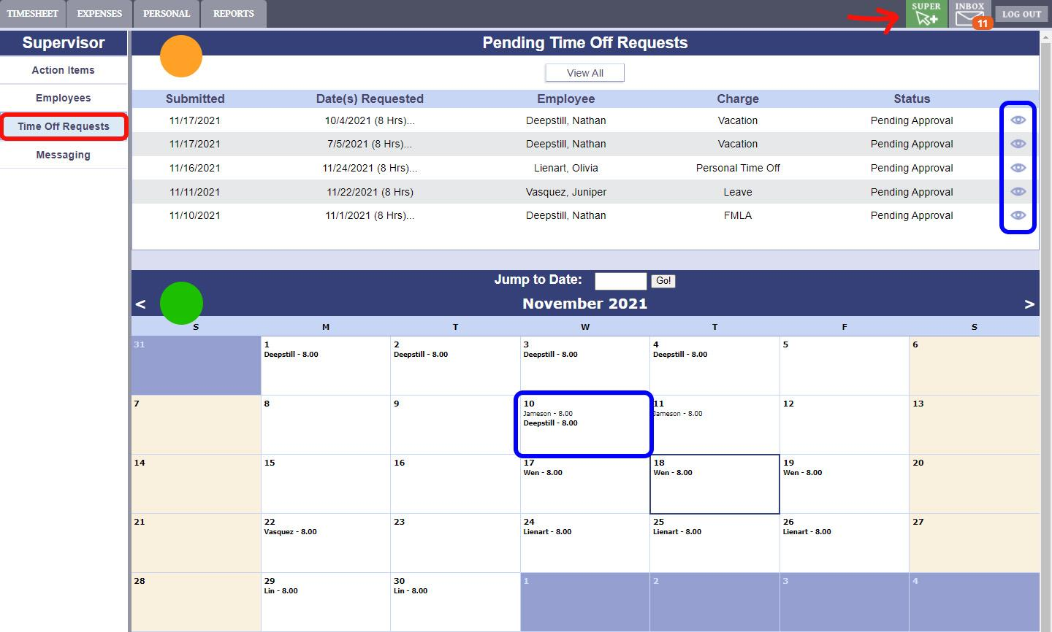

| On the request details page is a breakdown of everything you need to know about the employee's request.   1. Current leave balance available, plus a warning if their leave balance is not enough. 2. List of dates and times requested 3. Employee's Comments.   To Approve or Deny the Request:   1. Change the Status Dropdown to be “Pending,” “Approved,” or “Denied” as required. 2. Add Supervisor Comments 3. Click “Save” to apply the changes. If approved, the request will automatically place the time onto the timesheet. |  |
| --- | --- |

# Running Reports

As a Supervisor, you may have access to a set of reports, based on the permissions that your Administrators set. These reports will allow you to acquire information about individuals that you supervise. To see all available reports to you as a supervisor, click on the reports tab. Reports will cover subjects like printable timesheets, status of timesheets, weekly hours, etc. Ask an Administrator if you do not know which report will give you the information you are looking for.

1. Click on the “Reports” tab on the top menu.
2. The list of reports you have permission to run. Click on any of the light blue headers to expand or retract that report section. Click on the name of a report to see more about it.
3. The currently selected report. Click "Open Report" in the bottom right of this are to begin running it.
4. A list of your previous reports. To see it again, click a report to select it, and then "View".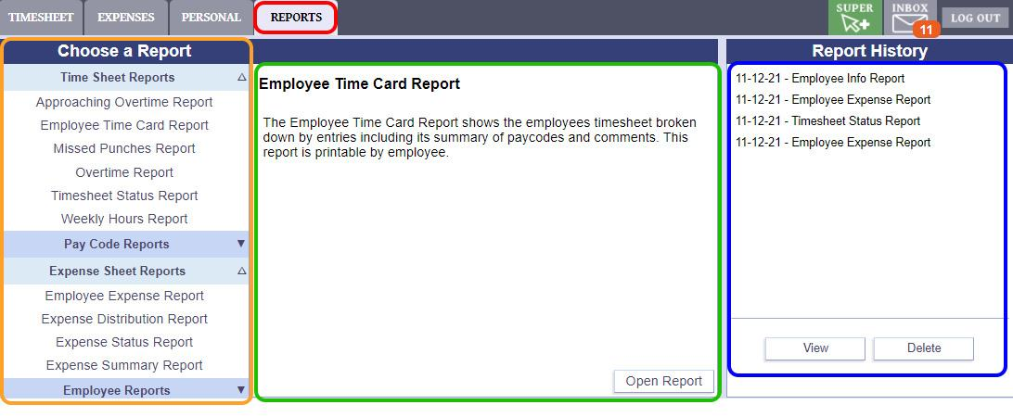

# Report Options

Each report has its own options for filtering and displaying its information.

1. The name the report will have once it's finished and listed in the Report History
2. Choose a single pay period, or a custom range of dates to gather data from
3. Limit your report data using any number of these filters
4. Additional options that control how the report appears
5. When you're finished with settings, click "Generate" to run the report.

Your report may take a few minutes to run, depending on your settings.

If you wait on this page, the results will be shown to you automatically when they're ready. You can also close this page, and the report will continue running. Either way, the results will be available in the Report History area when it's finished.

# Report Display

Once a report is run you can then view the report's results from the Report History list. This is an example result set of an Employee Time card report.